

Swinburne University of Technology
Lab01
REPORT
Applied Machine Learning - COS30082
Student Name: Truong Ngoc Gia Hieu
Student ID (VietNam): SWS01217
StudentID (Australia): 105565520
- Data Laoding and Initial Exploration
- Firstly, I download dataset named Titanic_Dataset.csv from the following Kaggle link (https://www.kaggle.com/datasets/yasserh/titanic-dataset). Next, I display all data in the file.
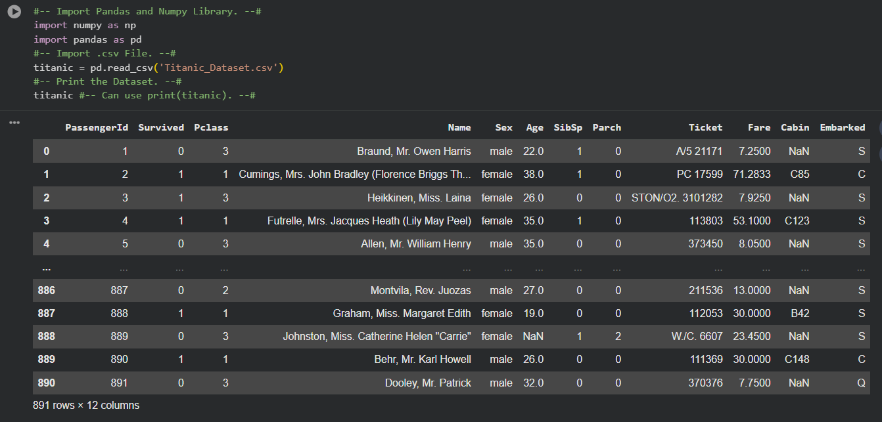
Figure 1: Titanic dataset preview loaded in Python
- Then, I used the .info() method to display the column names, non-null value counts, and data types of the dataset.
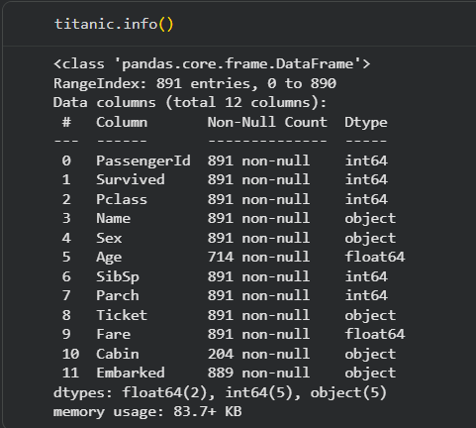

Figure 2: Titanic dataset info and data types preview

- Consequently, I utilized .describe() for calculating and showing descriptive statistics for the numerical columns.
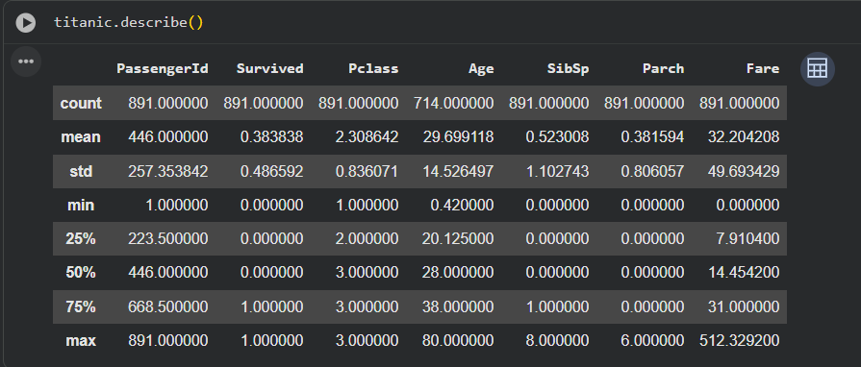
Figure 3: Descriptive statistics of the Titanic datasets
- In Drawing Graph part, I decide to draw a bar chart to showcase relationship between Sex(Gender => X) and Survived(Y)
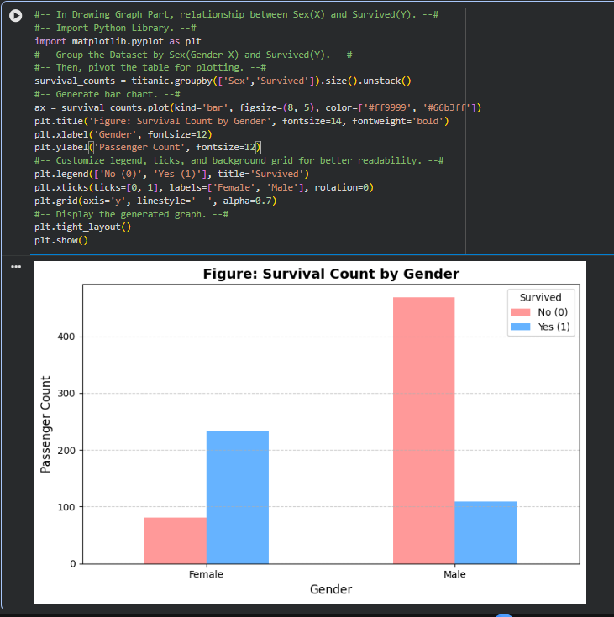
Figure 4: Survival count by Gender Distribution
Dataset and Visualization Summary:
The Titanic dataset highlights information on 891 passenge with following feature of each customer including passenger class, gender, age, and survival status. Moreover, the bar chart above showcases the relationship between gender and survival outcomes, clearly revealing a significant disparity where female passengers had a substantially higher survival ratio compared to male passengers.

- Extended Data Exploration and Analysis
To further explore the Titanic dataset, additional exploratory data analysis (EDA) was conducted to identify potential relationships between passenger characteristics and survival outcomes.
Firstly, a comparison between passenger class (Pclass) and survival status (Survived) was performed. The visualisation helps determine whether travelling class had an influence on survival probability. The analysis indicates that passengers travelling in higher classes generally achieved better survival outcomes compared to those travelling in lower classes.
Secondly, the age distribution of passengers was examined using a histogram. This visualisation provides an overview of the age range represented in the dataset and identifies the age groups that make up the majority of passengers. Understanding the age distribution is important for determining whether age may play a role in survival outcomes.
Furthermore, a boxplot was created to investigate the relationship between passenger age and survival status. By comparing the age distributions of survivors and non-survivors, it becomes possible to observe whether certain age groups experienced higher survival rates during the disaster.
In addition, the relationship between ticket fare (Fare) and survival status was analysed. Since ticket fare is closely associated with passenger class and travel conditions, examining this feature provides additional insight into factors that may have influenced survival outcomes. The visualisation suggests that passengers who paid higher fares generally had a greater likelihood of survival.
Finally, a correlation heatmap was generated to examine relationships among the numerical variables within the dataset. The heatmap highlights the strength of correlations between features and helps identify variables that may be useful for future machine learning modelling.
Overall, the extended exploratory analysis provides a deeper understanding of the Titanic dataset and reveals several factors that appear to be associated with passenger survival. These findings may assist in selecting relevant features for future predictive machine learning models.

